**AISC2013 - Deployment of AI Solutions**

**FINAL EXAM**

**GROUP – F**

|  |  |  |
| --- | --- | --- |
| **NAMES** | **STUDENT ID** | **CONTRIBUTION** |
| Laxmi Sharma | 500211675 | Developed a Salary Prediction Web App and pushed the code into GitHub public repository |
| Ajay Kundu | 500210975 | Containerized the application using Docker and successfully ran it. Pushed and pulled docker image into/from Docker Hub Public Repository. |
| Nikita Wadhwa | 500203529 | Generated a detailed word report, engaging in a discussion about Web app and Docker repositories with Ajay |
| Jashanpreet Kaur | 500211597 | Crafted a comprehensive PowerPoint presentation and held a discussion with Laxmi regarding the application and docker work representation. |

1. **Choose an Application Topic**

Salary Prediction Web App using Streamlit, VSC and python

1. **Create a Machine Learning Model for salary Prediction:**

Created a Machine learning model to learn from Stackover Flow’ 2020 Data of Software Engineerss Salary.

<https://insights.stackoverflow.com/survey>

1. **Save the model and use it in our Web App**

Saved the ML model and used it in our prediction app to predict the salary.

1. **See the results of analysis.**

There are 2 features on Web app – Explore and Predict. We can see the result of predicted salary on predict page and we can see the statistics of data on Explore page.

1. **Upload your application’s code on GitHub.**

<https://github.com/LaxmiSharma247/Deployment_Of_AI_Solutions_Final>

1. **Creating a Docker container and pushing the Docker image to the Docker Hub public repository.**

Docker Hub Public Repository: <https://hub.docker.com/r/akundu22/deploymentofaisolutionapp>

1. Here, we are building our Docker file and name it as “deploymentofaisolutionapp”.

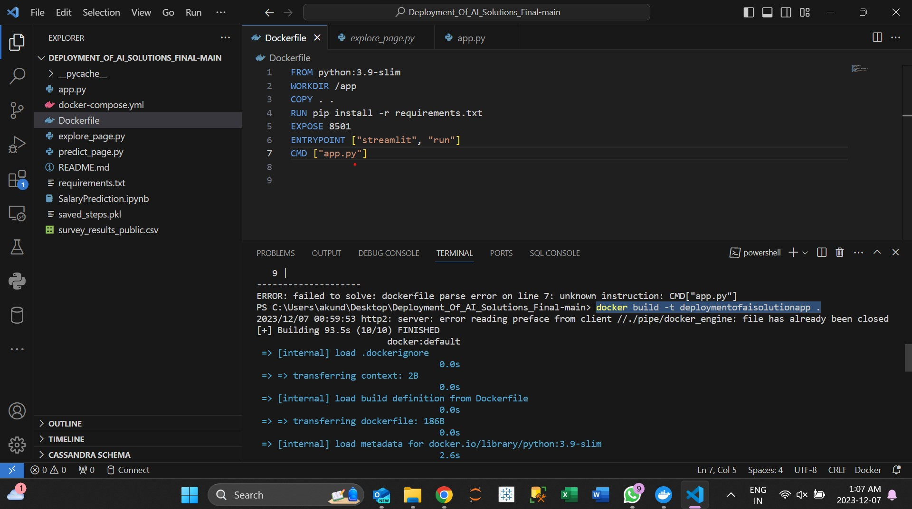

2. Here, we run our Docker file built above.

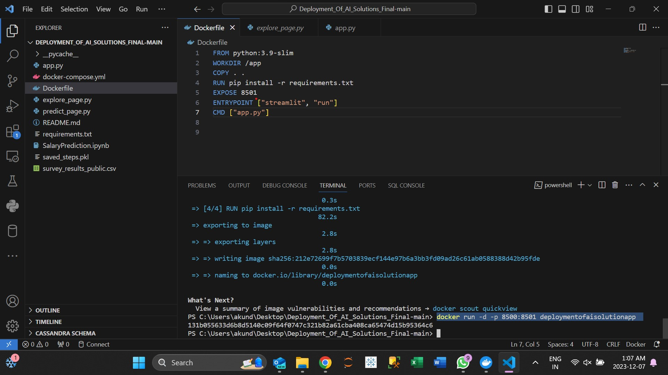

3. Here, we go for Docker login to authenticate with the registry.

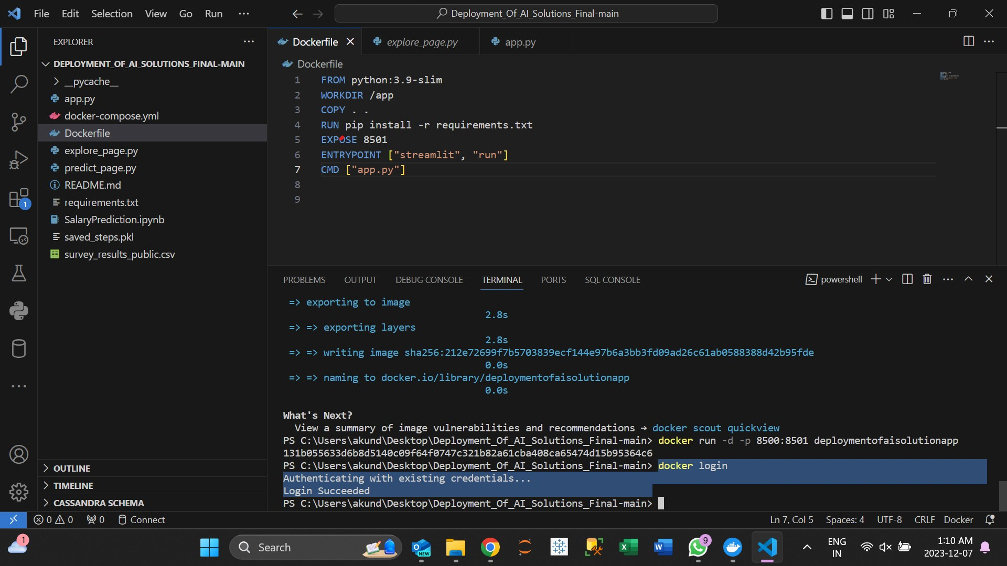

5. We tag our account with the hub having username “akundu22” into our Docker file and check for the images.

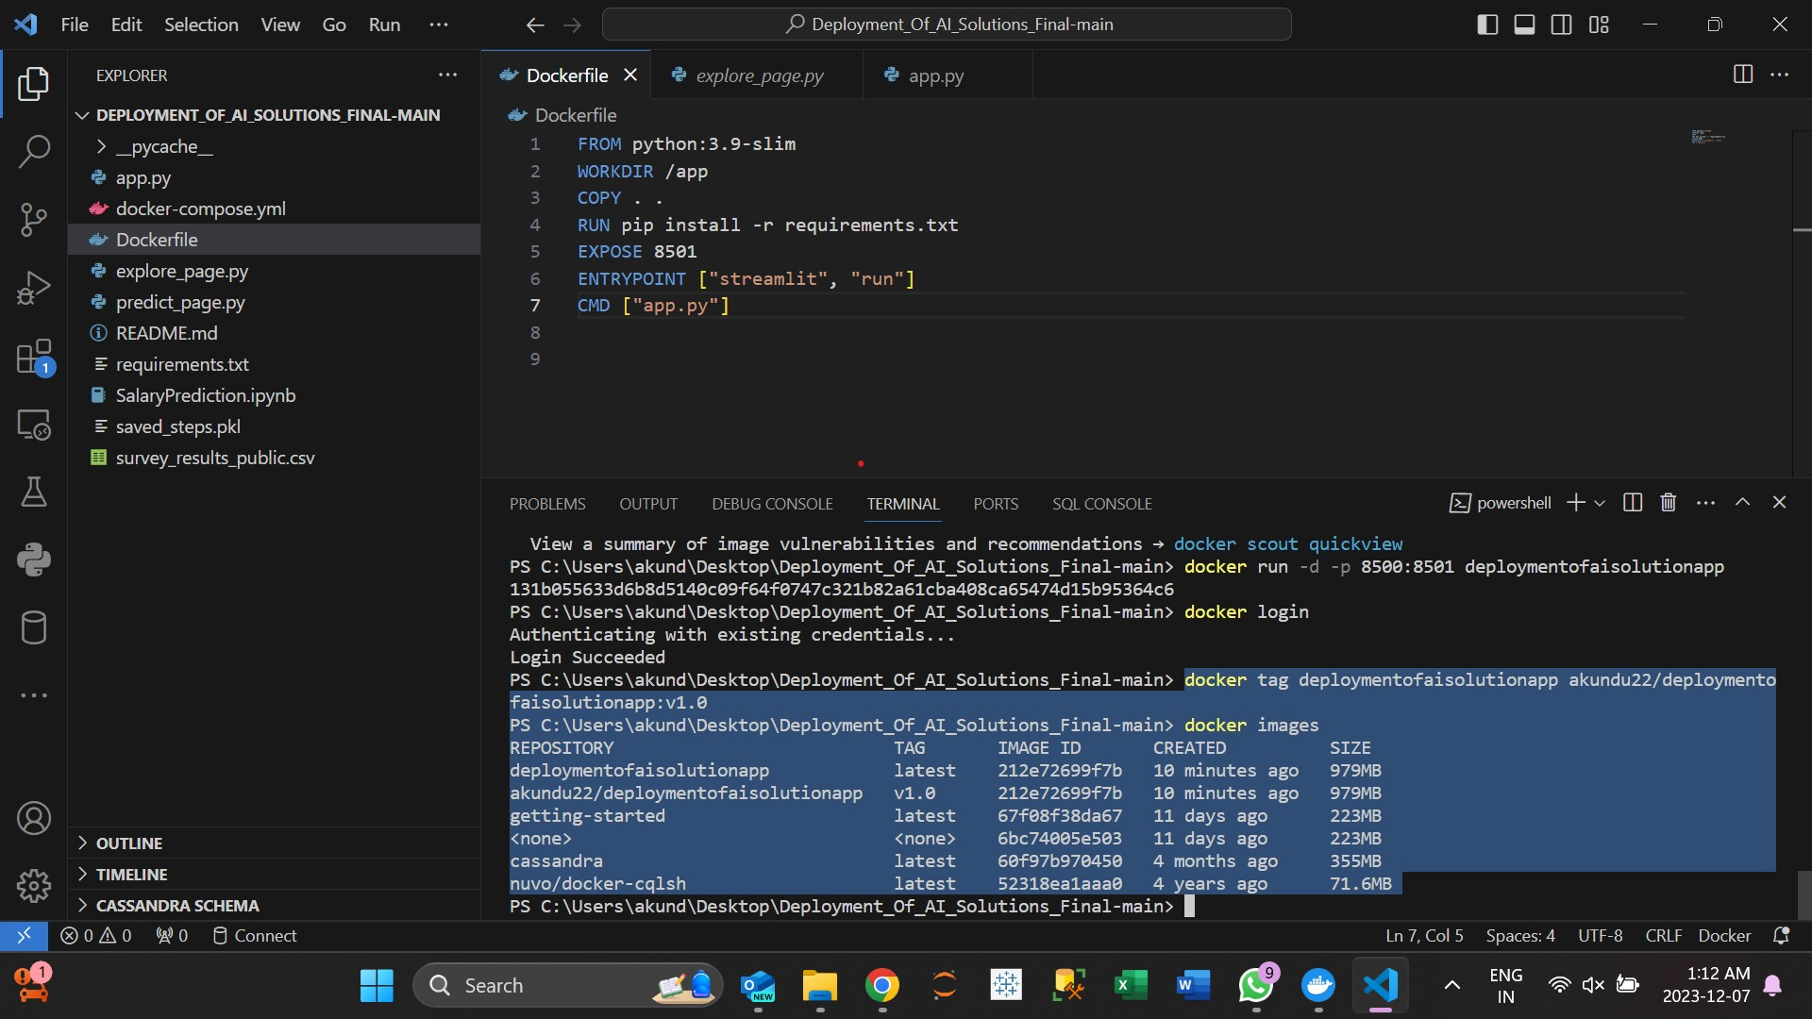

6. We can see that our file is empty right now.

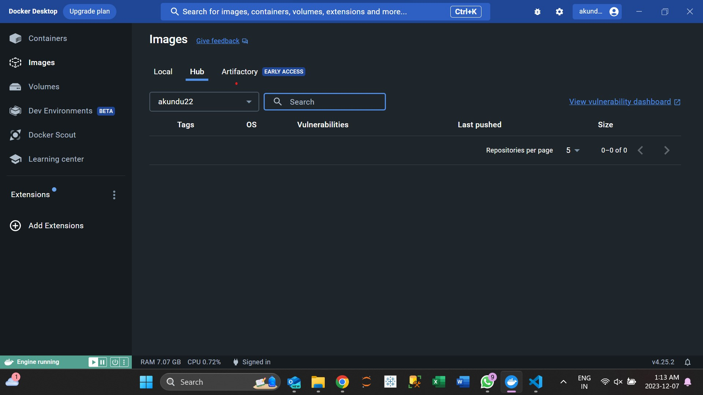

7. Now, we use ‘push’ command to upload a local Docker image to a container registry. This will make the images available to others.

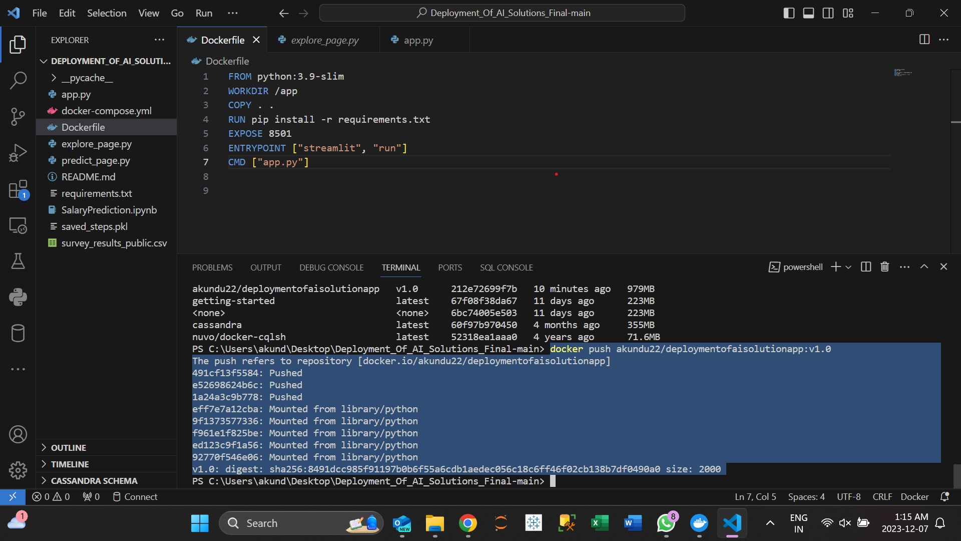

8. We can see the folder on our hub repository now.

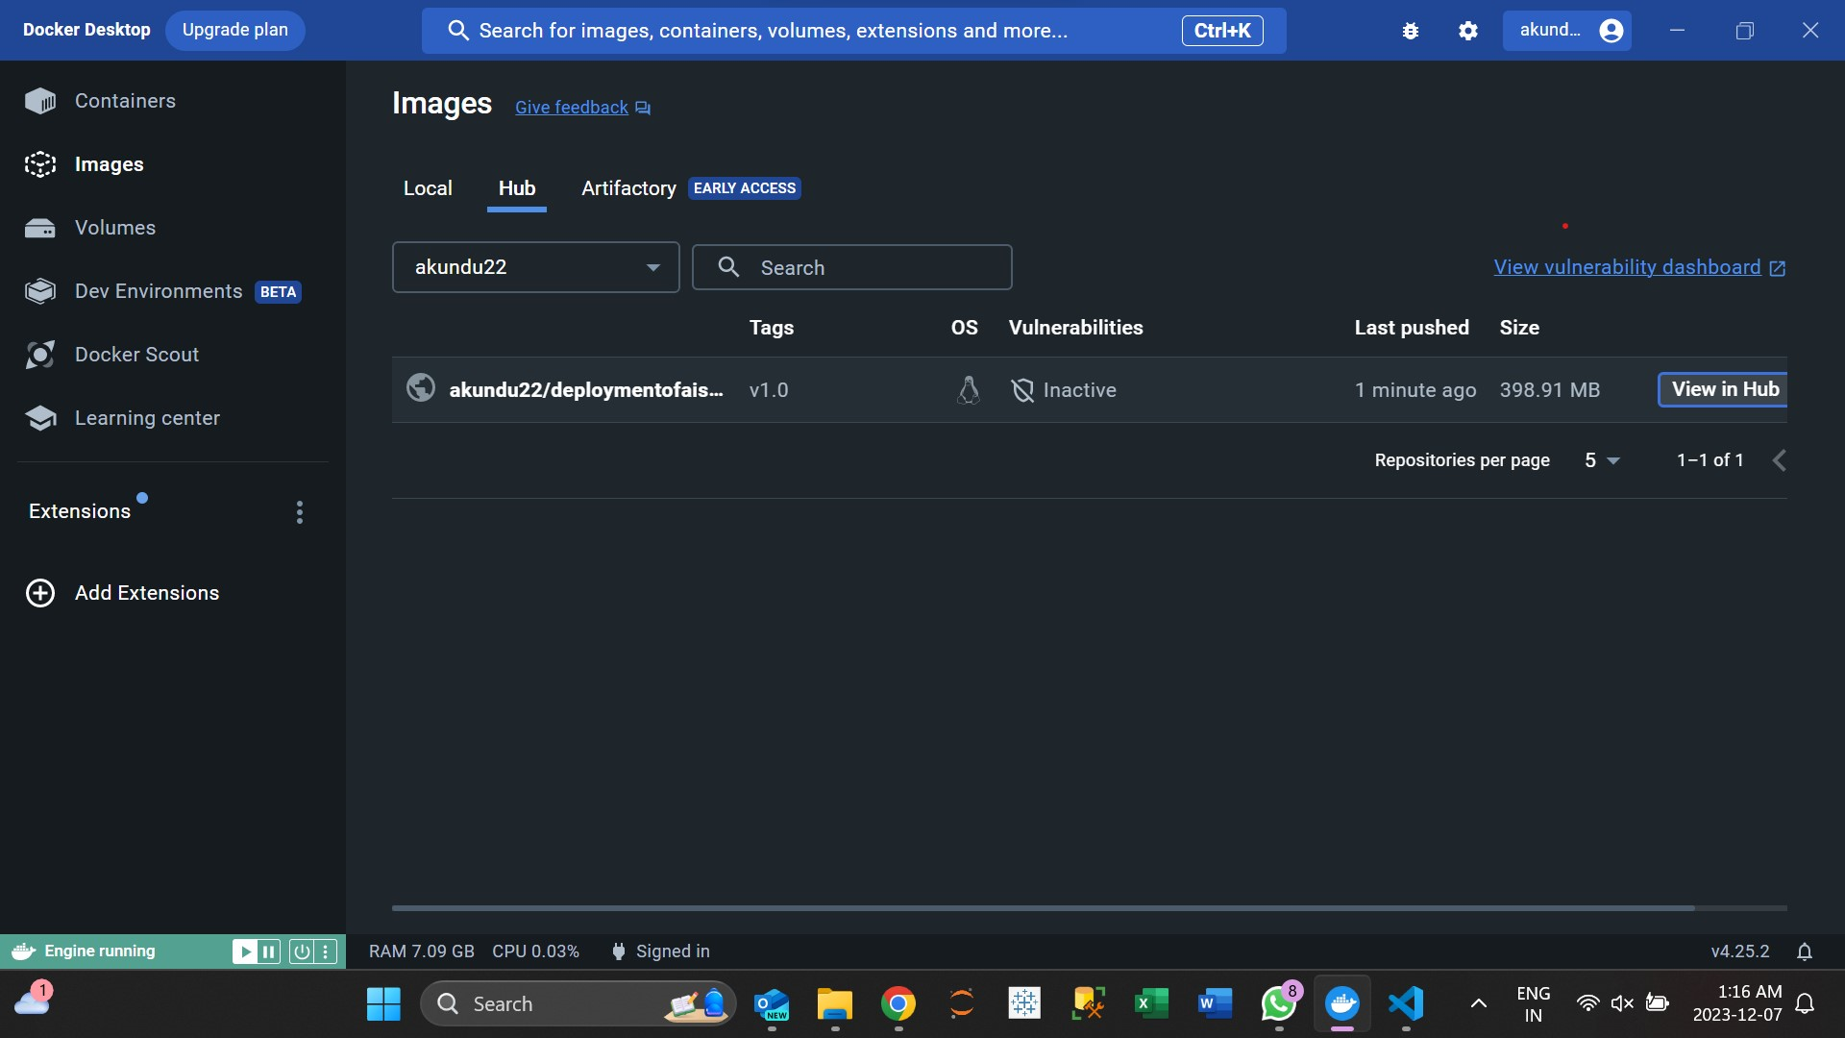

9. This is our Docker Hub.

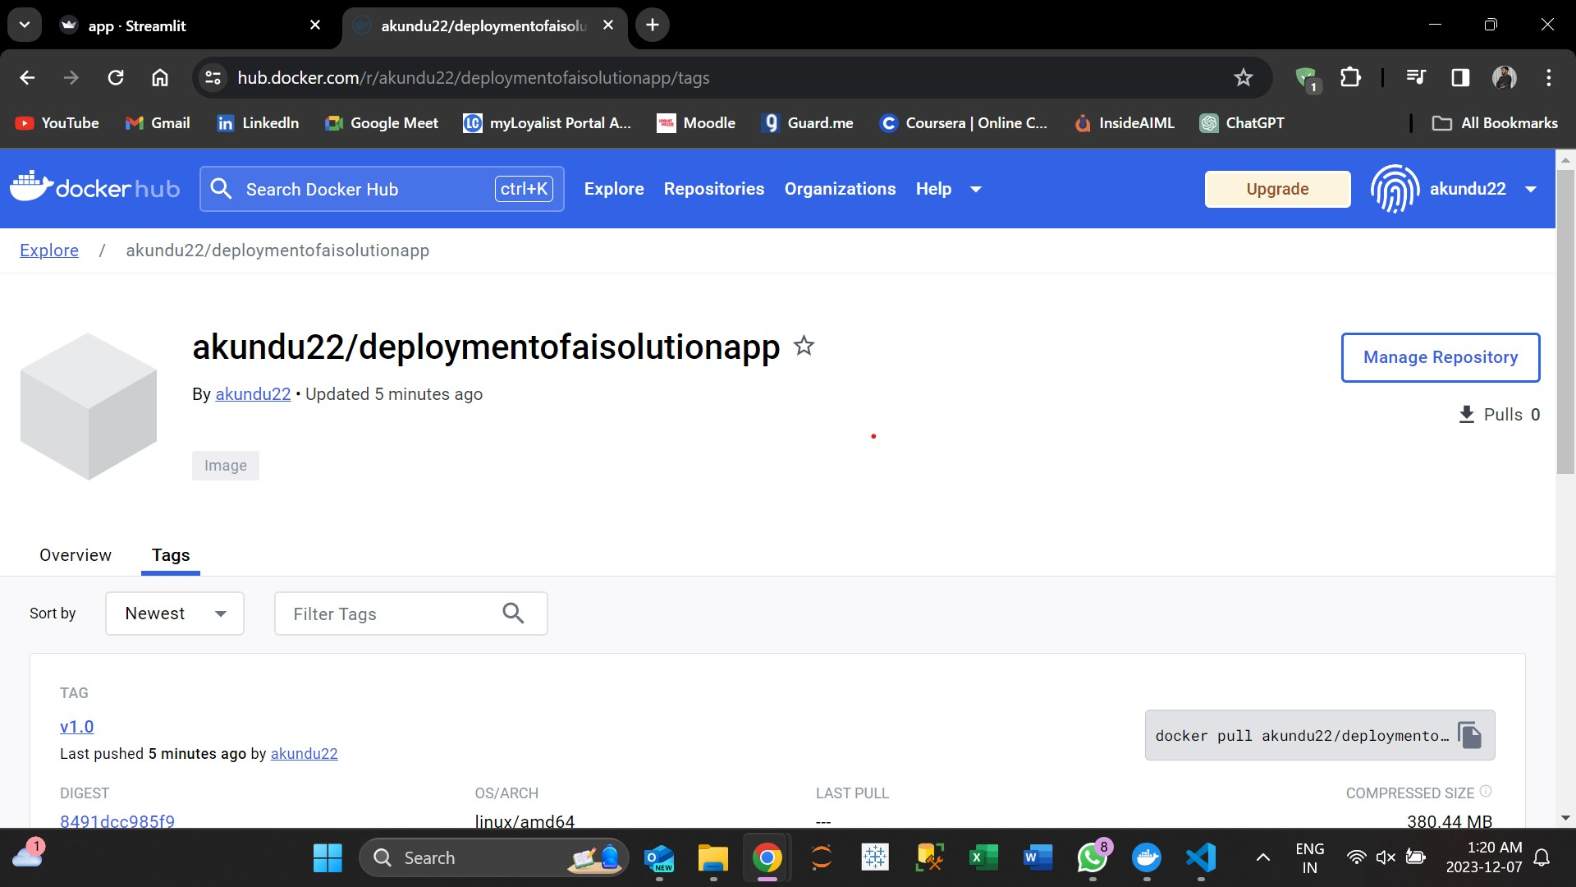

10. Here, we can see the images in our Hub repository.

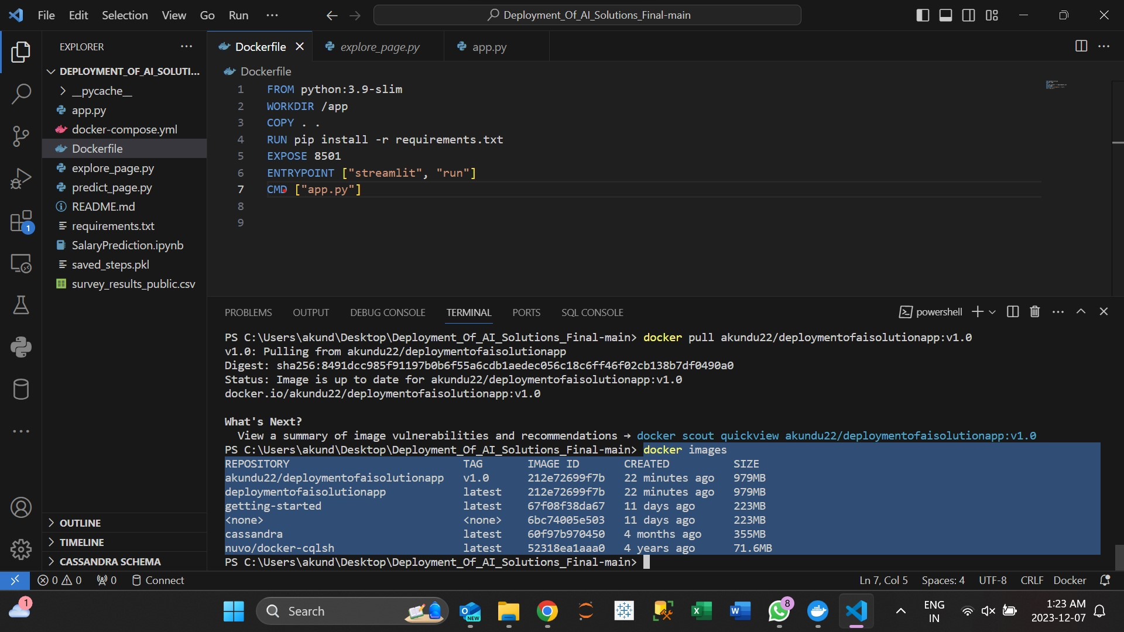

11. We are using ‘rmi’ command to remove (or delete) the Docker images from our local machine.

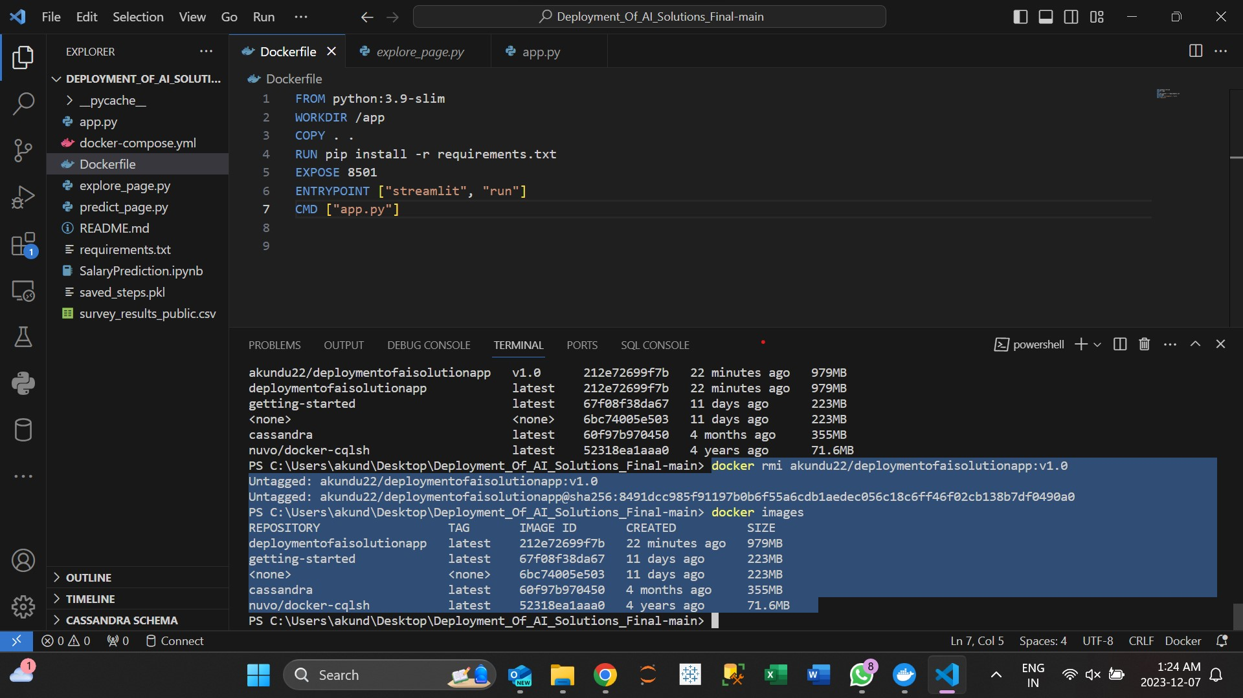

12. Here, we run the ‘pull’ command to download a Docker image from a container registry to the local machine. And we can see the images back in our local machine.

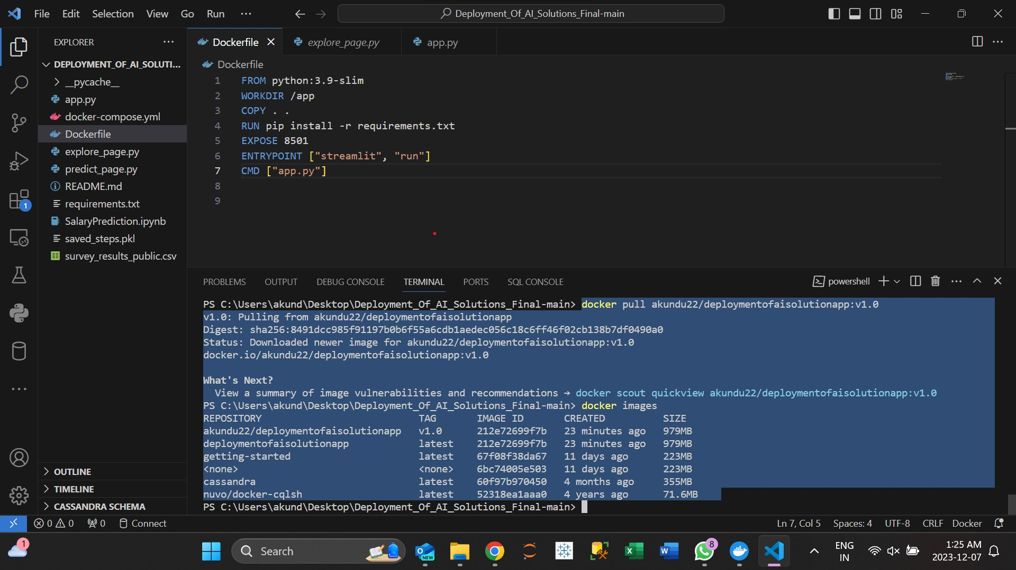

1. **Running the app using the image from the public repository.**

We are operating an application designed to forecast and analyze salaries across various occupations, countries, educational backgrounds, and years of professional experience.

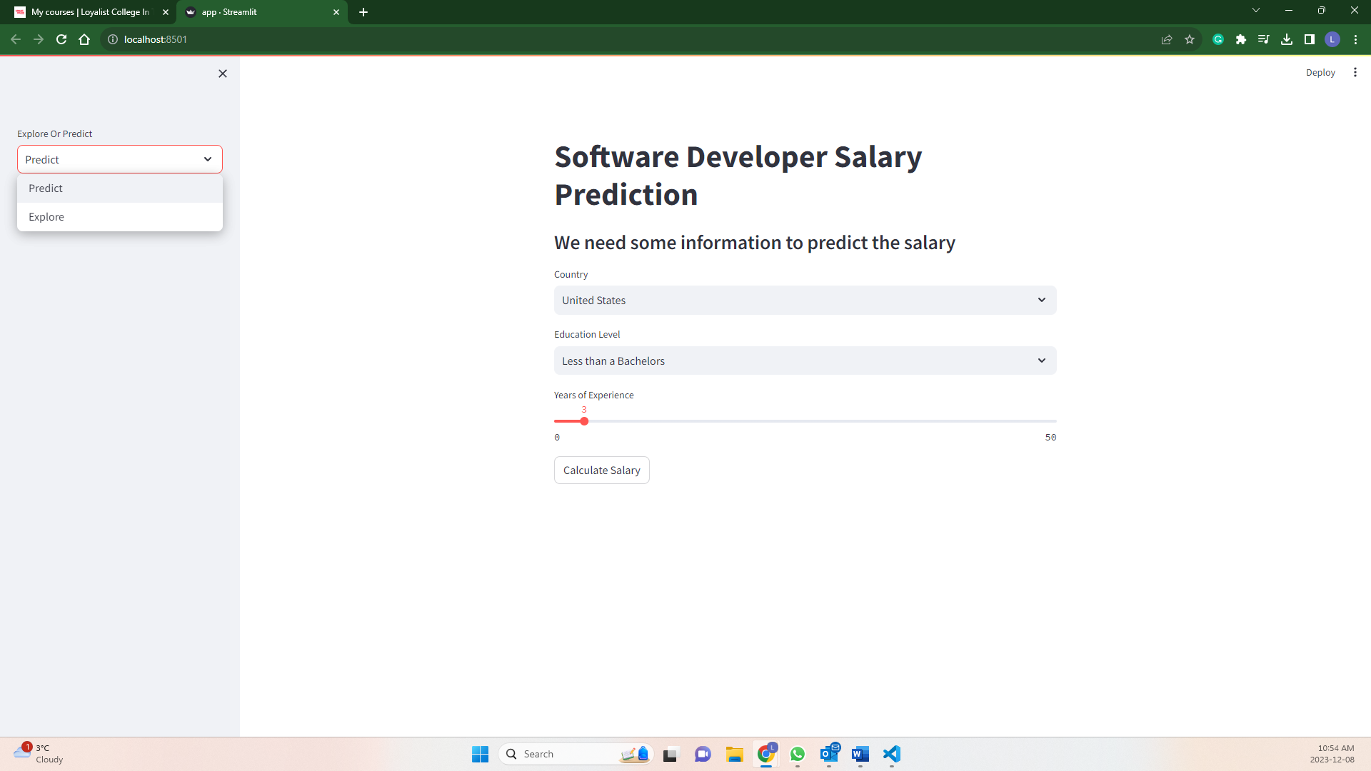

**Default Prediction:**

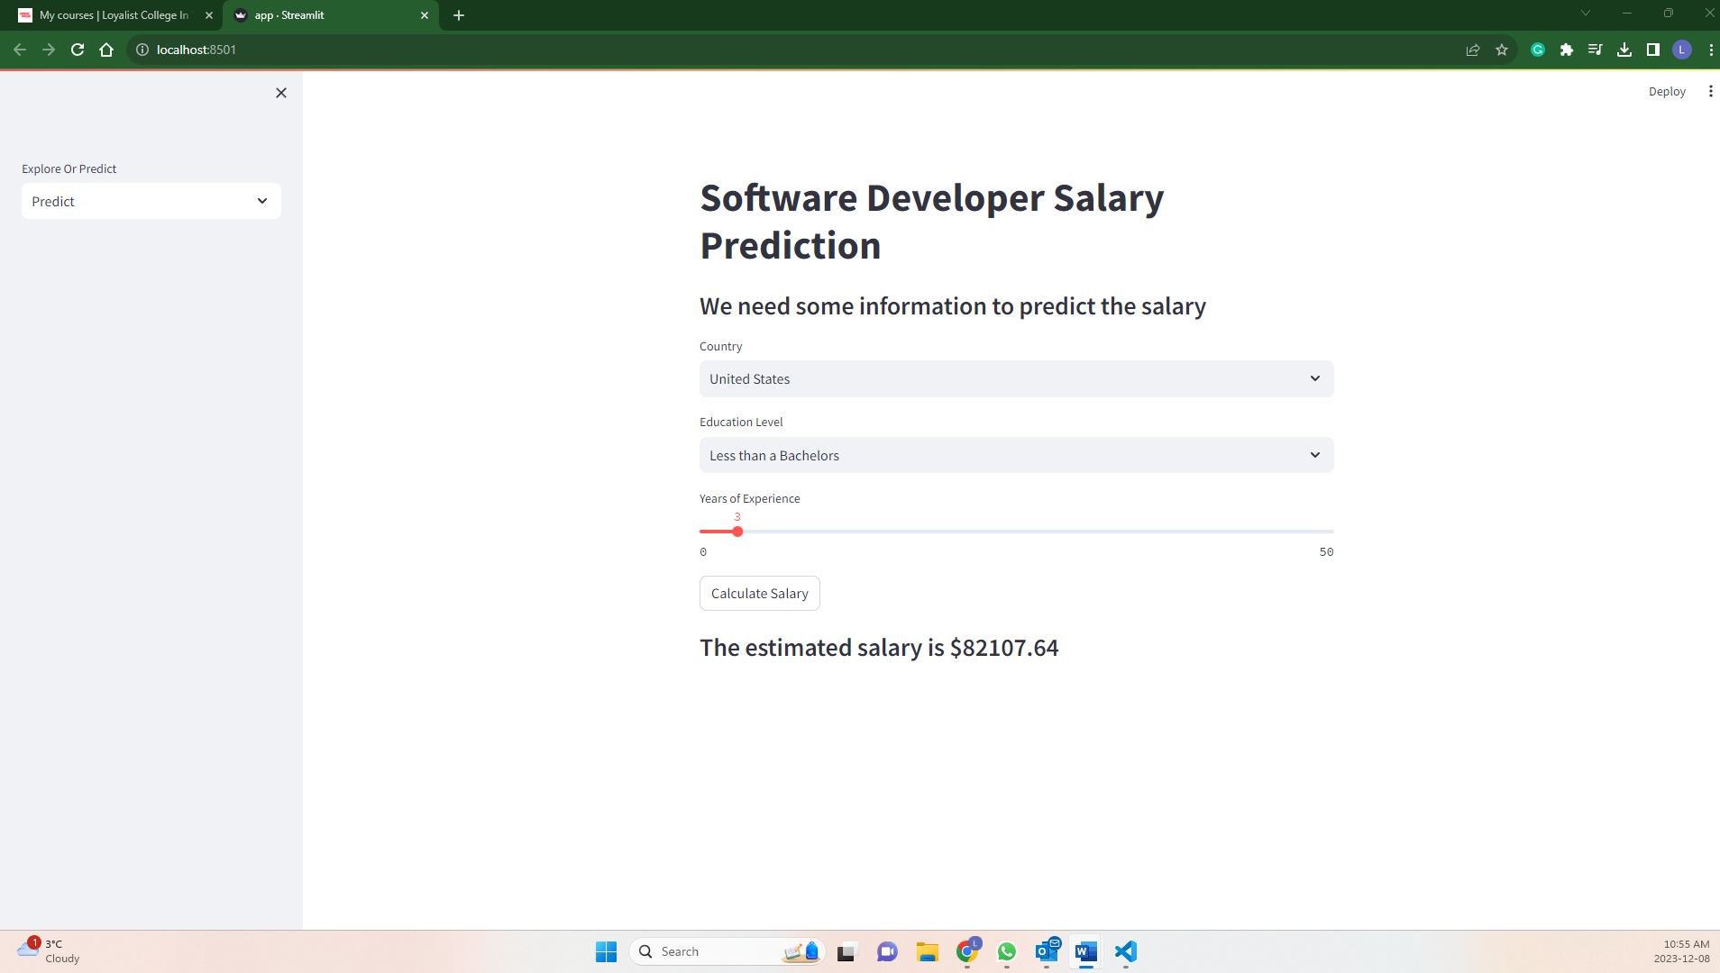

App can predict the anticipated salary for a U.S.-based software developer with a bachelor's degree and with 3 years of experience.

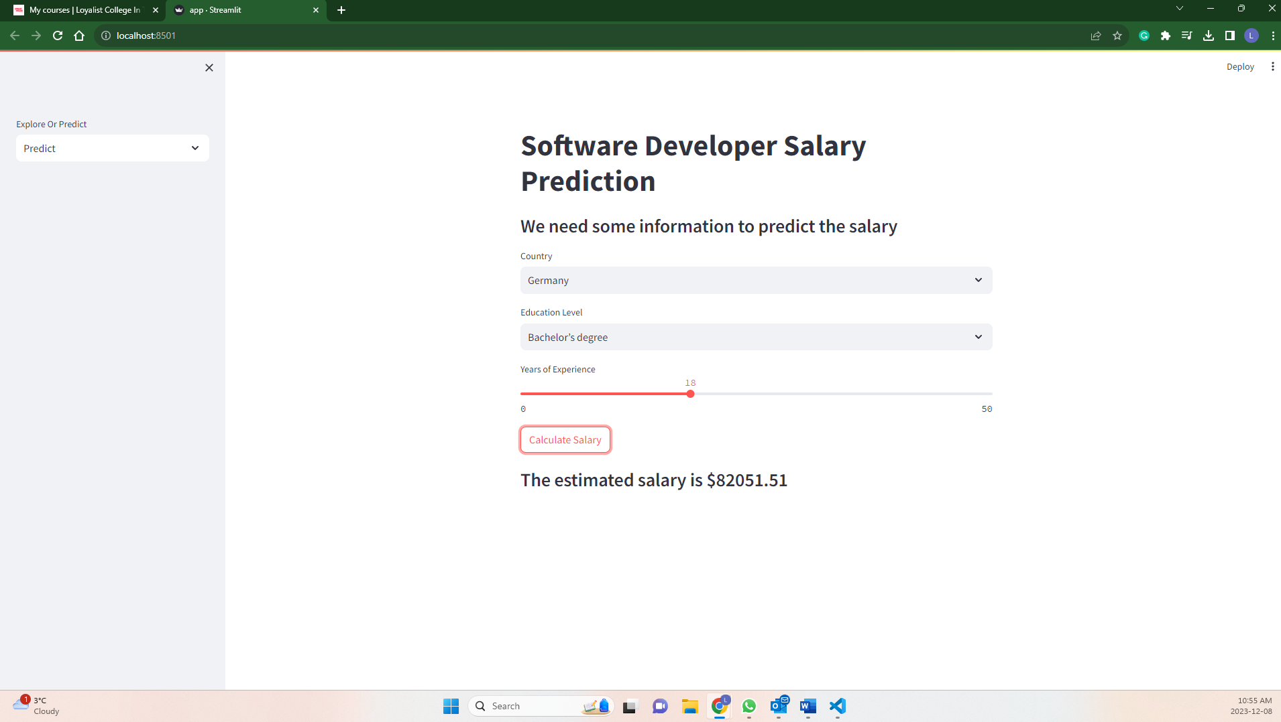

Additionally, the application provides insights into how this prediction evolves when the individual holds a bachelor's degree and accumulates 18 years of experience.

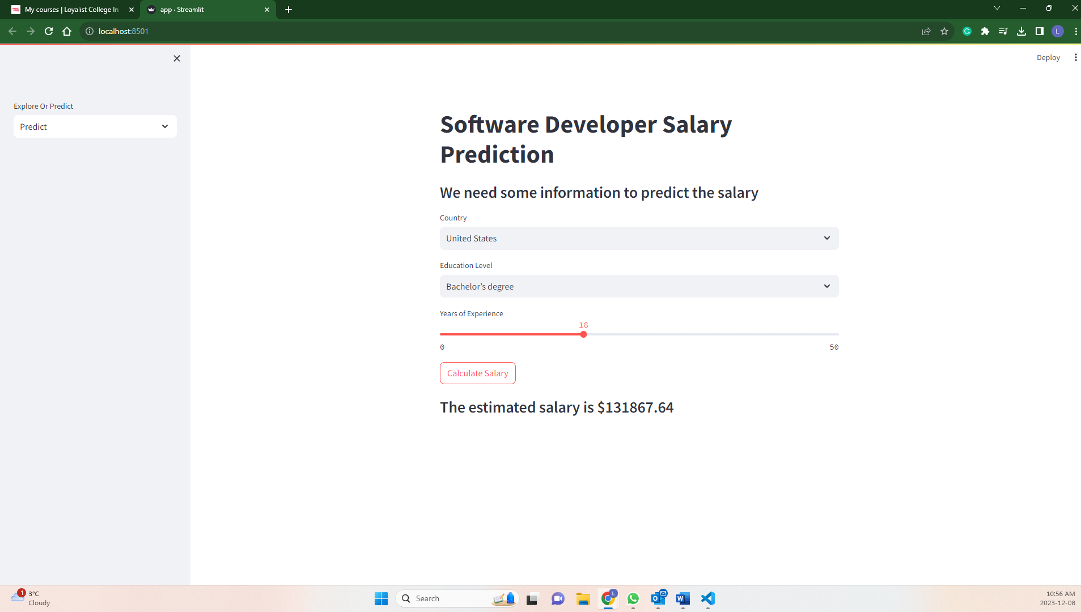

**Explore feature:**

Here, our focus is on exploring the salaries of Software Engineers in different countries based on historical data. The accompanying pie chart illustrates that the dataset is predominantly sourced from the United States (36.9%), with the Russian Federation contributing the smallest share at 2.6%.

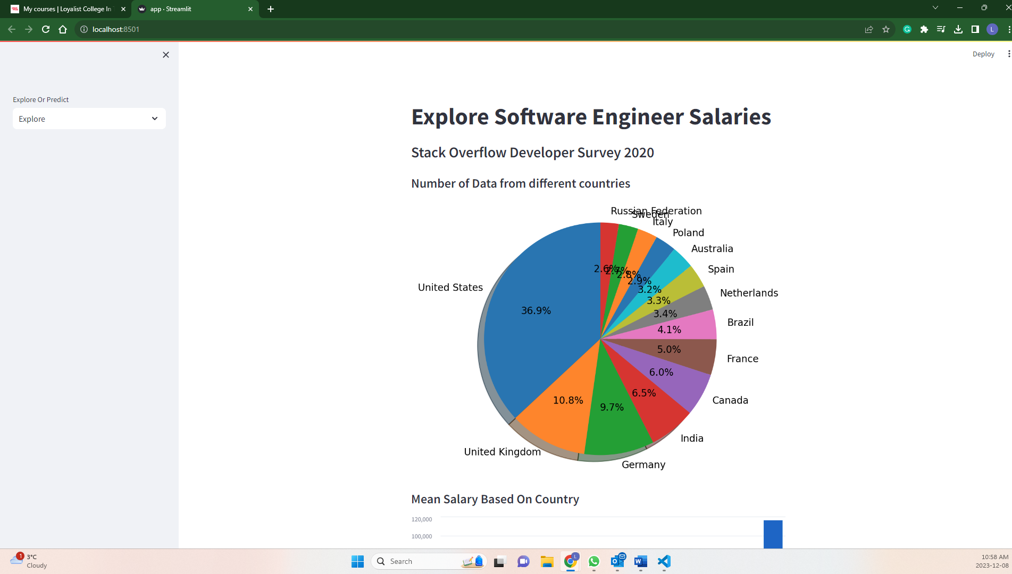

From the bar graph, we observe that the United States boasts the highest average salary (approximately $115,000), while Brazil exhibits the lowest mean salary among the featured states.

While from this line graph, we can discern the trends – whether there is an upward or downward trajectory – in mean salary in relation to the increasing number of years of professional experience.

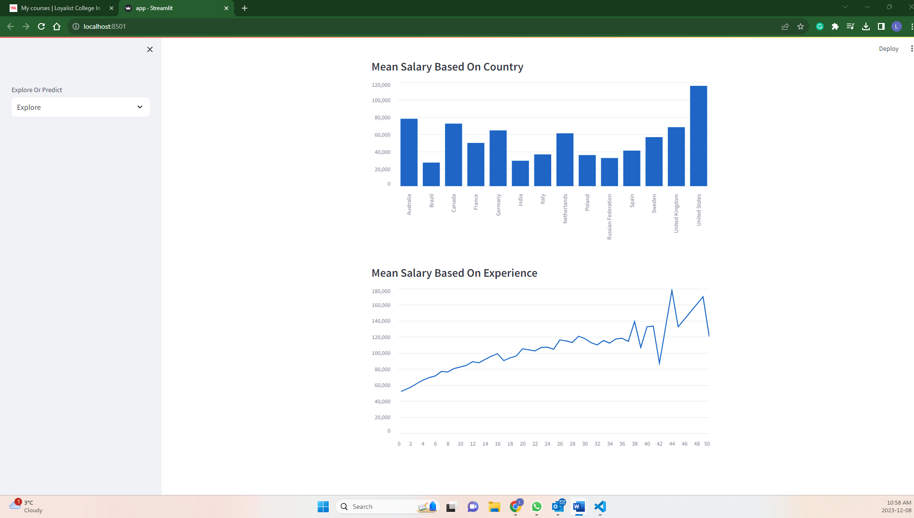

**REFERENCE:**  
<https://www.youtube.com/watch?v=xl0N7tHiwlw&list=RDCMUCbXgNpp0jedKWcQiULLbDTA&start_radio=1>

<https://insights.stackoverflow.com/survey>